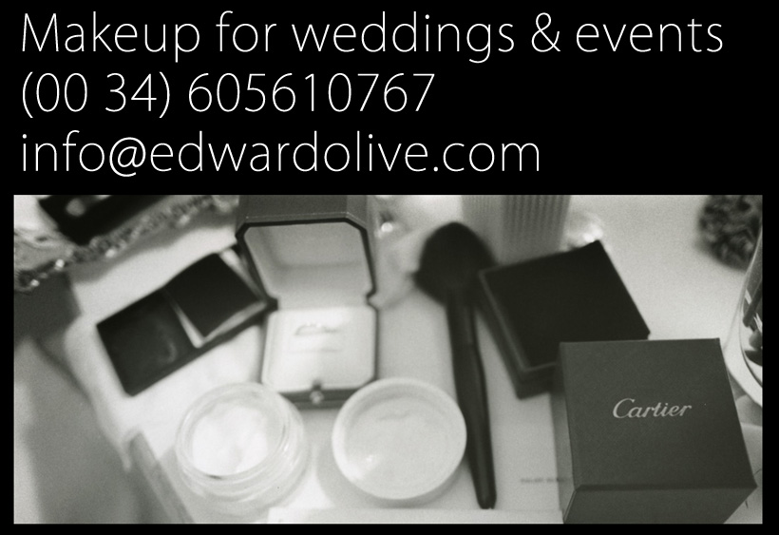

**Professional makeup for weddings & events in Spain**

**Makeup artists for brides and family Madrid & Spain**

Edward Olive, award winning wedding photographer, offers an exclusive service of professional makeup for weddings, parties, birthdays and all types of social and business events, pre-wedding, post-wedding, portraits, photojournalism & corporate photography. To contract the make-up service contact us on:

Tel: 00 34 605610767

Email: edwardolive@hotmail.com

Web: <http://www.edwardolive.info/>  
Web: <http://www.edwardolive.com/>

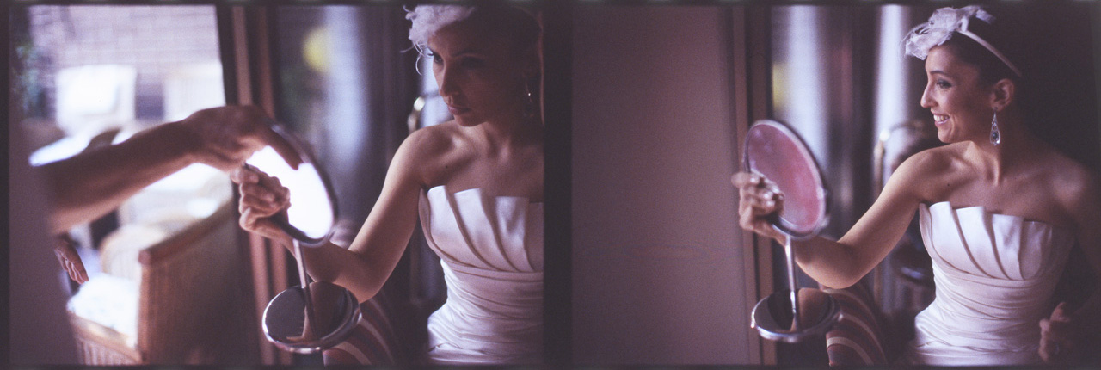

Professional makeup & styling for weddings, social and professional events, parties, model and actress books

Makeup artist who forms part of Edward Olive’s photography team for the specific makeup needs of the wedding, Portrait and fine art photographer.

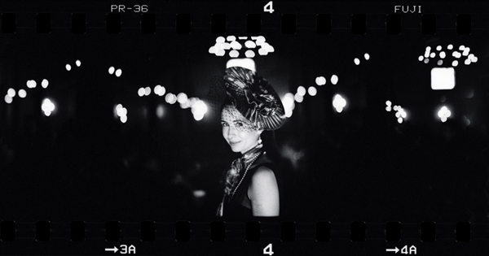

Fee rates for 2011 (for Madrid Capital Spain – for other venues consult by email):

* Service of makeup for brides:

- Test sessions (in client’s residence or hotel): consult pricing €

- Bridal makeup: consult pricing €

- Brides family (or other additional guests): consult pricing € per additional person

- Presence during the day of the event to retouch the bride and those friends and family contracting the makeup services from the beginning of the wedding or event to the start of the wedding party: consult pricing €

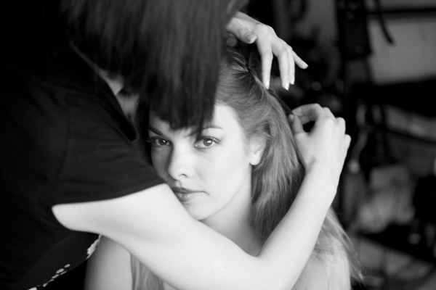

* Photo books

For actors, actresses, models & musicians

- Makeup for ladies & styling (including retouching during the photography session): consult pricing €

- Makeup for men & styling (including retouching during the photography session): consult pricing €

(Note all prices are for Madrid. For other locations in Spain & Europe contact us for prices)

* For all other makeup needs a specific estimate will be issued. Edward Olive portrait & wedding photography

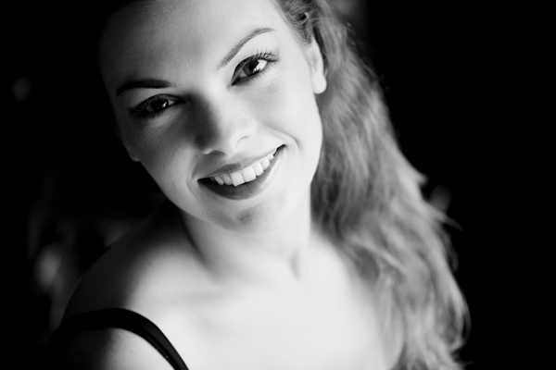

Edward Olive award winning portrait & wedding photography

Tel: 00 34 605610767

Email: edwardolive@hotmail.com

Web: <http://www.edwardolive.info/>  
Web: <http://www.edwardolive.com/>

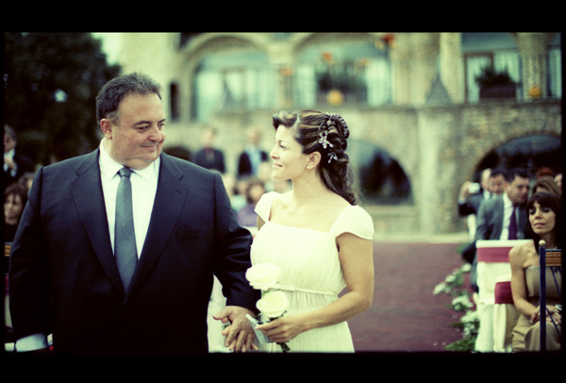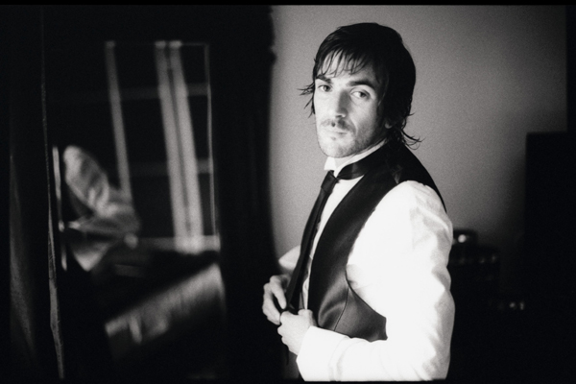

© All texts & photos Copyright Edward Olive

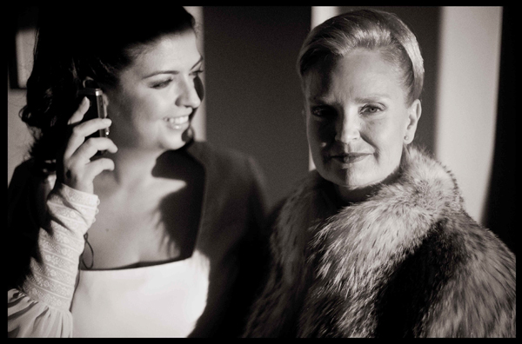

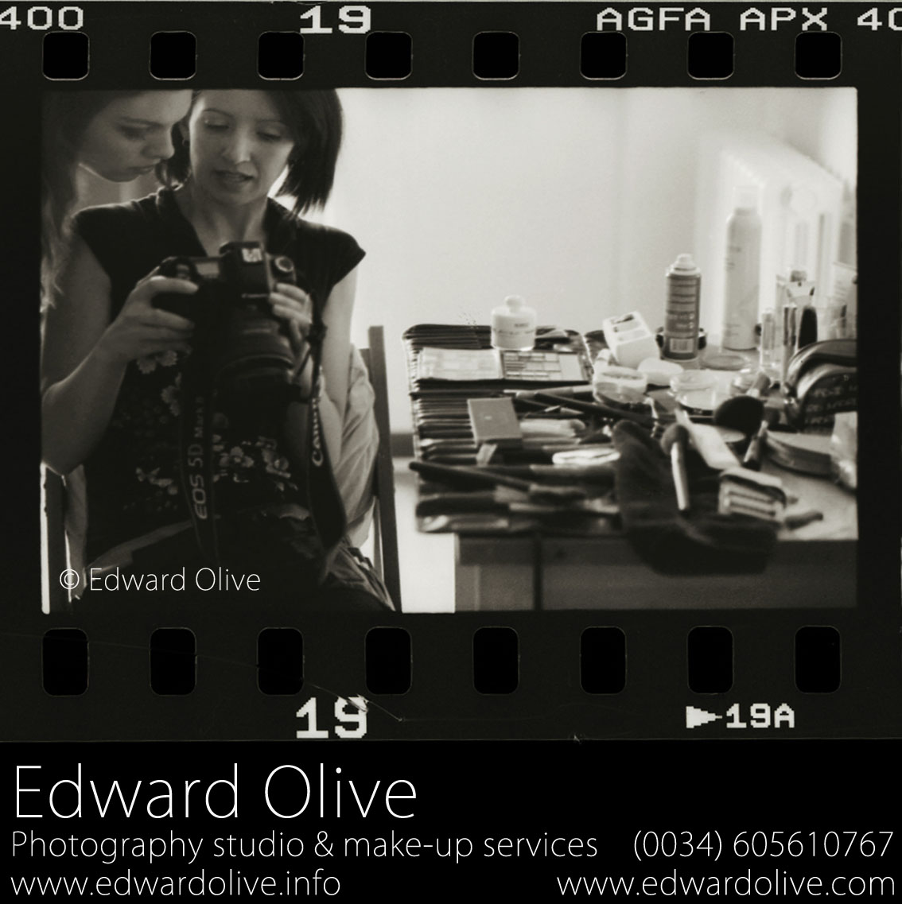

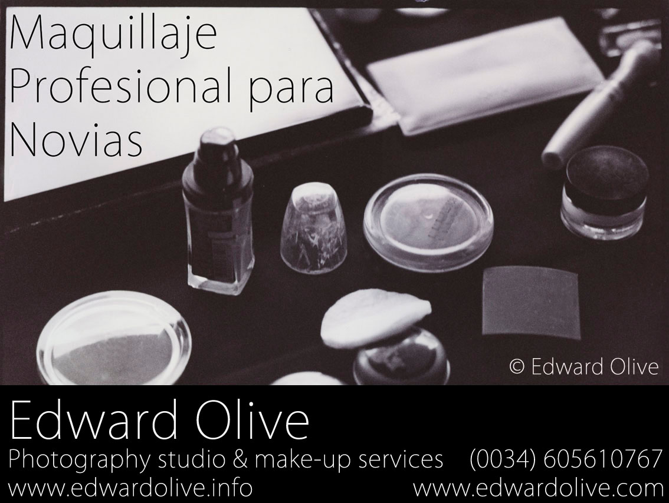

© All texts & photos Copyright Edward Olive

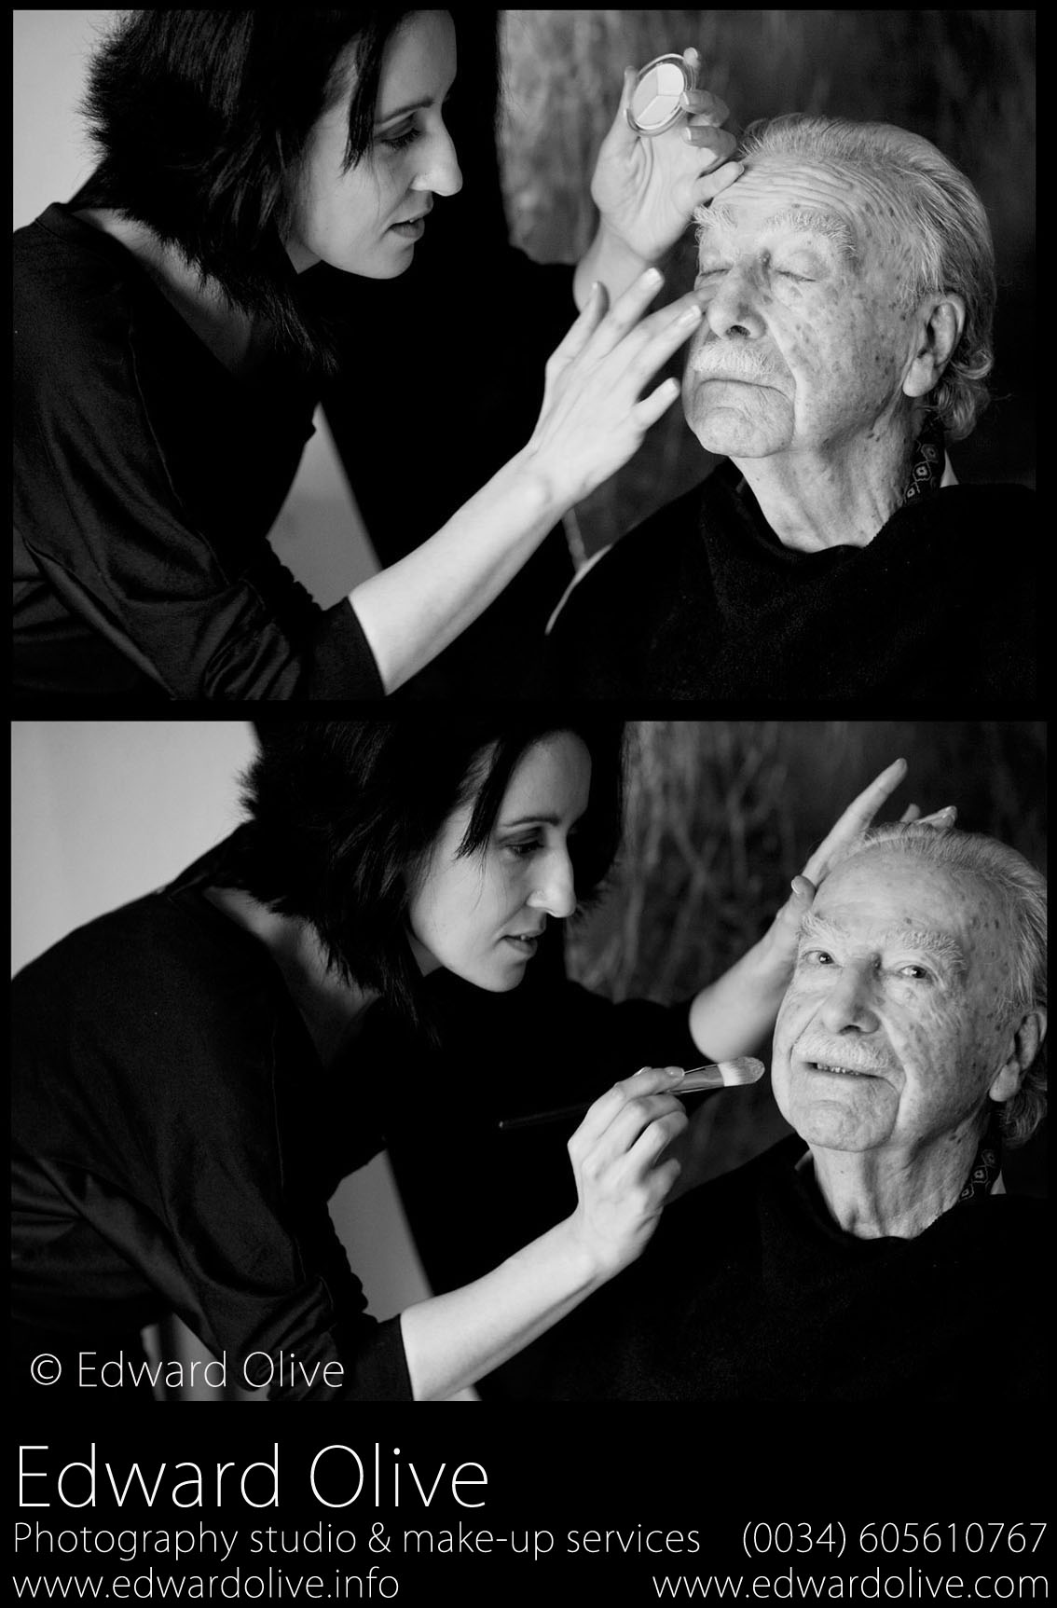

© All texts & photos Copyright Edward Olive

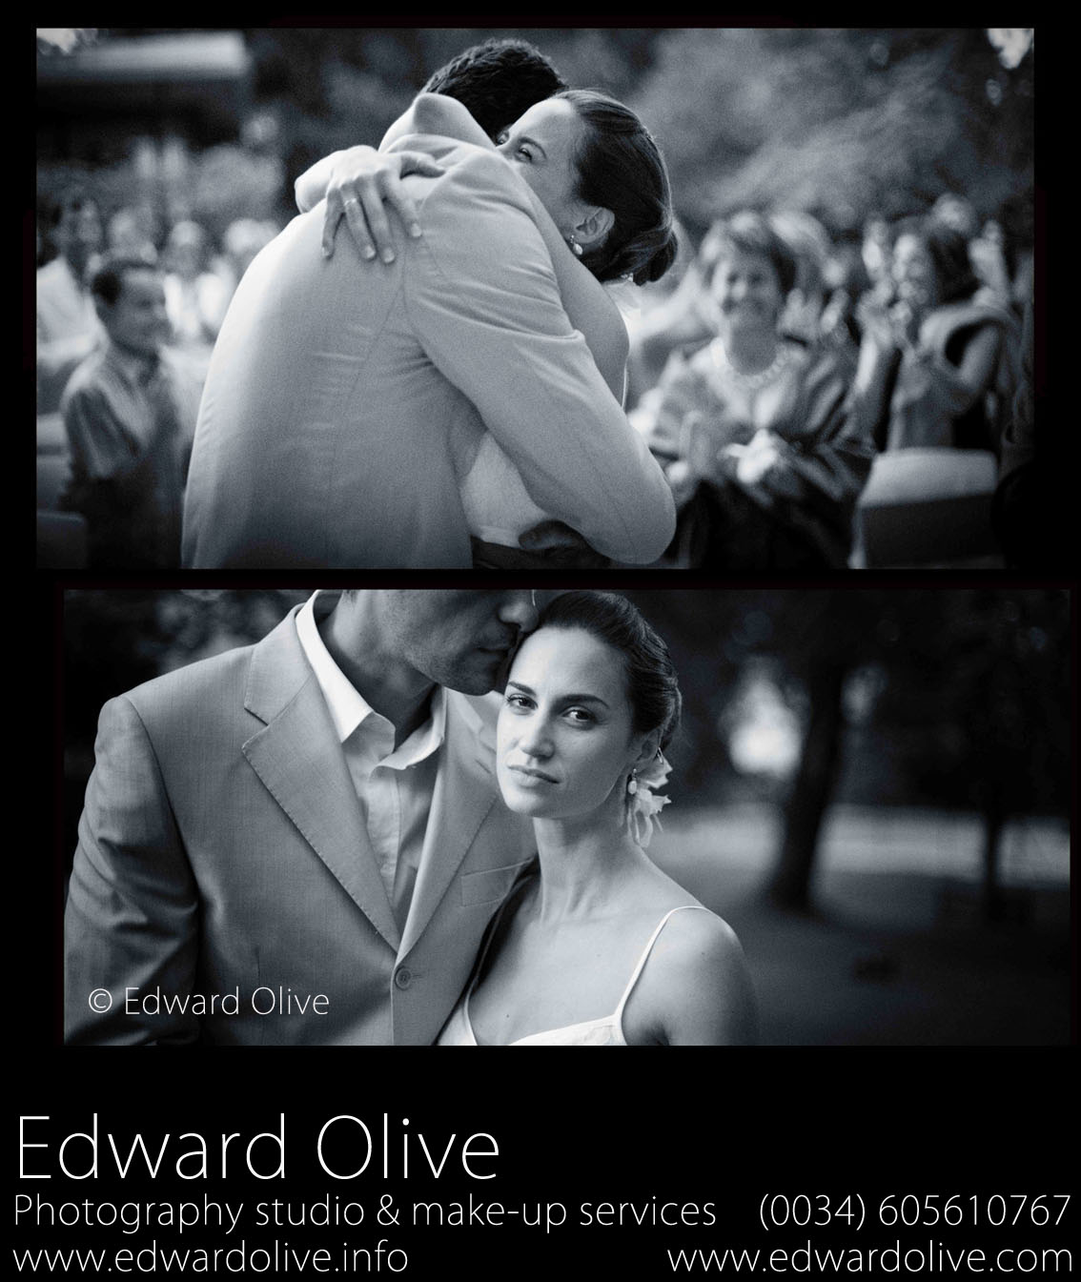

© All texts & photos Copyright Edward Olive

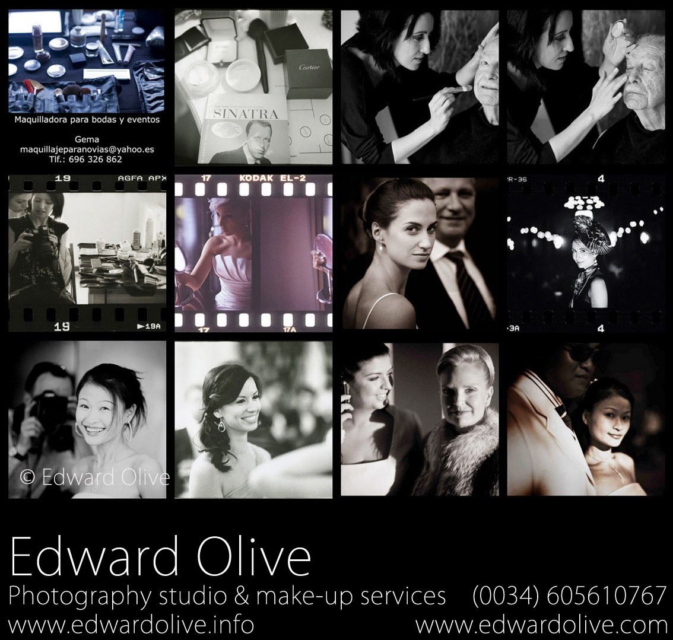

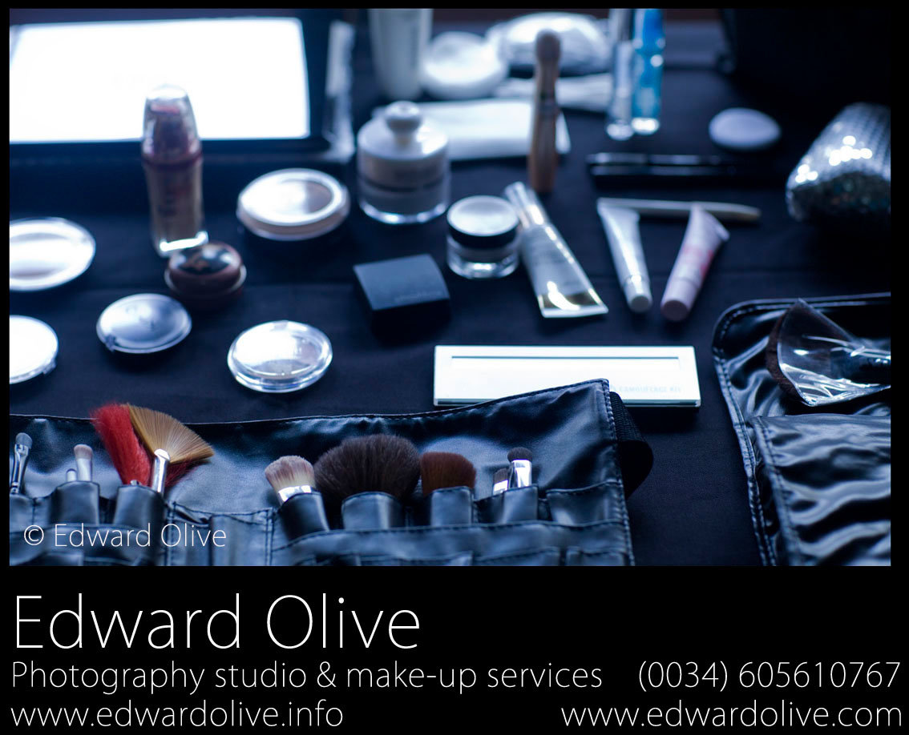

Edward Olive  
Photography  
Tel: 00 34 605610767  
Email: [edwardolive@hotmail.com](mailto:edwardolive@hotmail.com)  
Web: <http://www.edwardolive.info/>  
Web: <http://www.edwardolive.com/>  
  
© All texts & photos Copyright Edward Olive